Instructions for researching “Submitted File Status”
(Districts and Charters)

- Go to the School Finance web site at the following address.
http://www.ade.az.gov/schoolfinance/
- Select the link titled “Districts and Charters”.
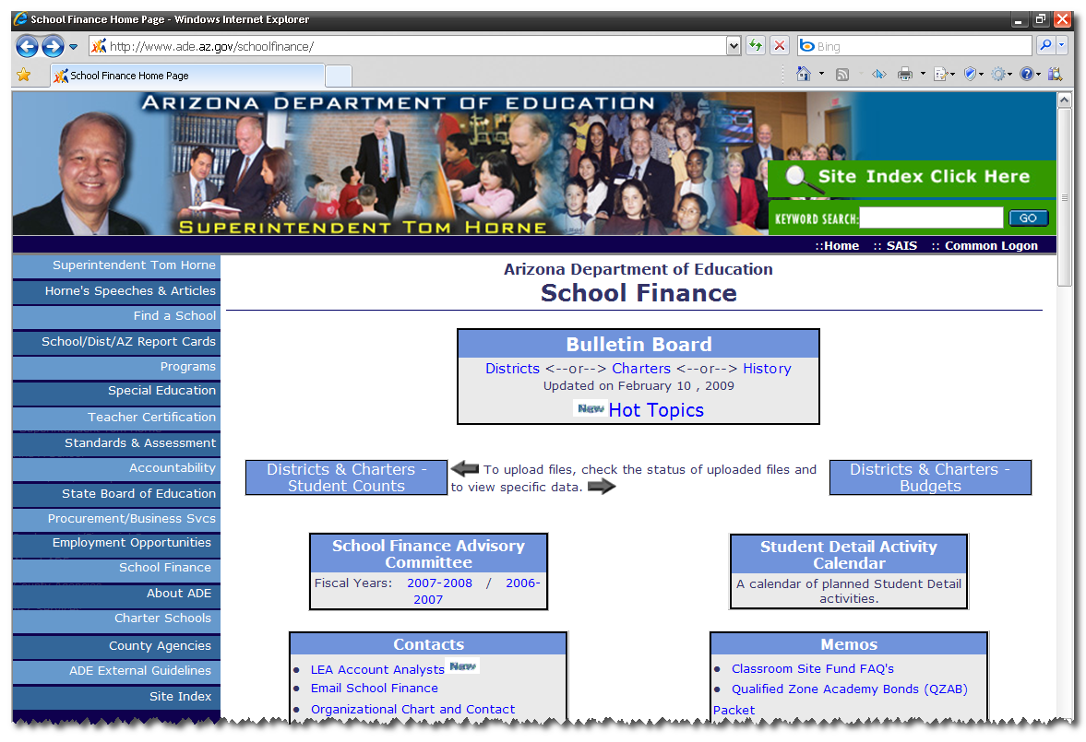

3) Click on the drop down list and select the district or charter you want to research
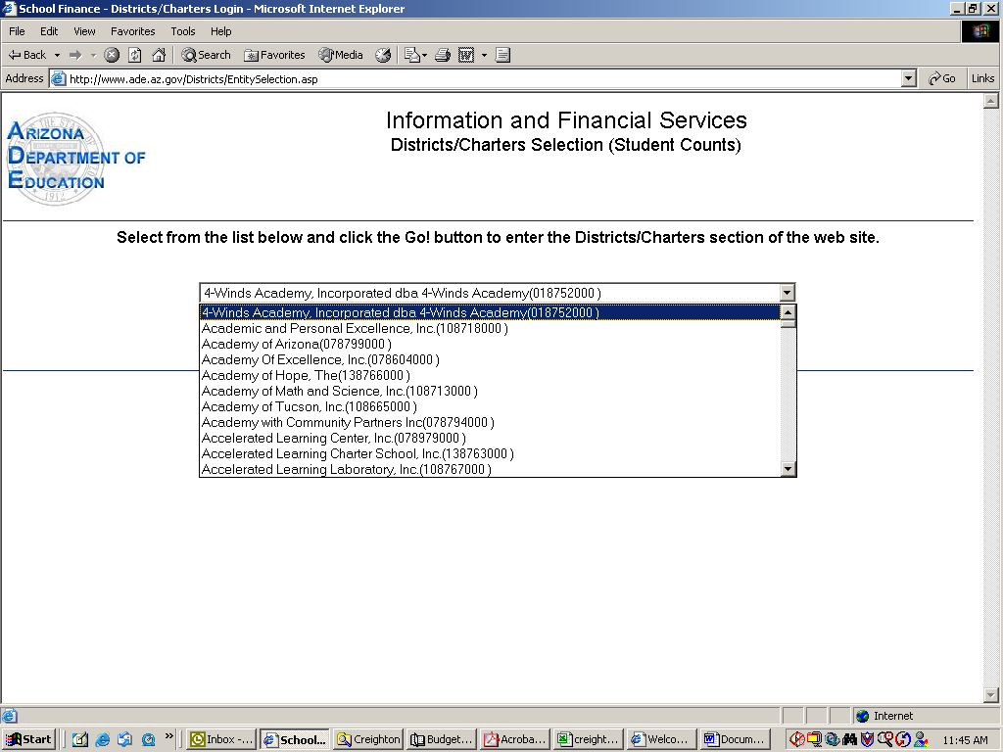

- After selecting the entity, click the “GO” button.

- Click the link in the upper right hand corner will enable navigation back and forth between the Budget and the Student Count System. When viewing Student Counts it will display “Switch to Budgets”.
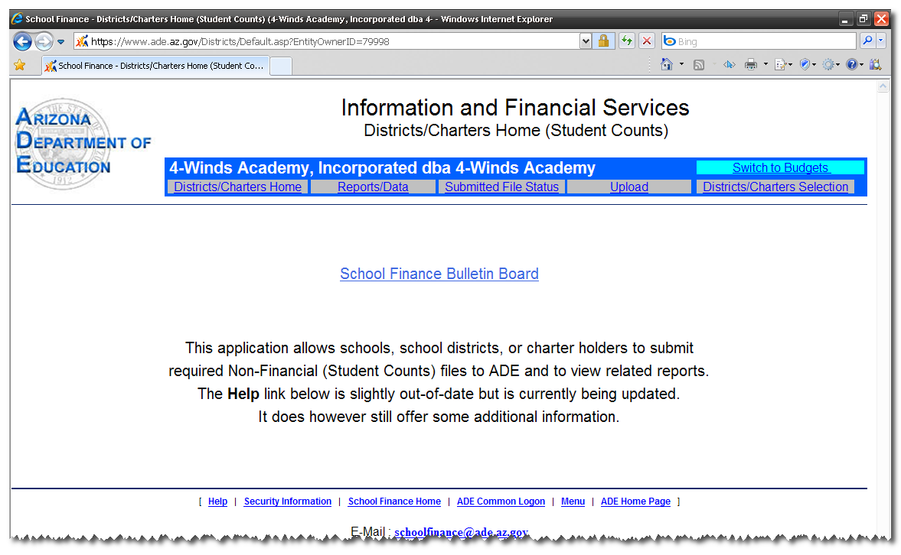

When viewing Budgets it will display “Switch to Student Counts”.
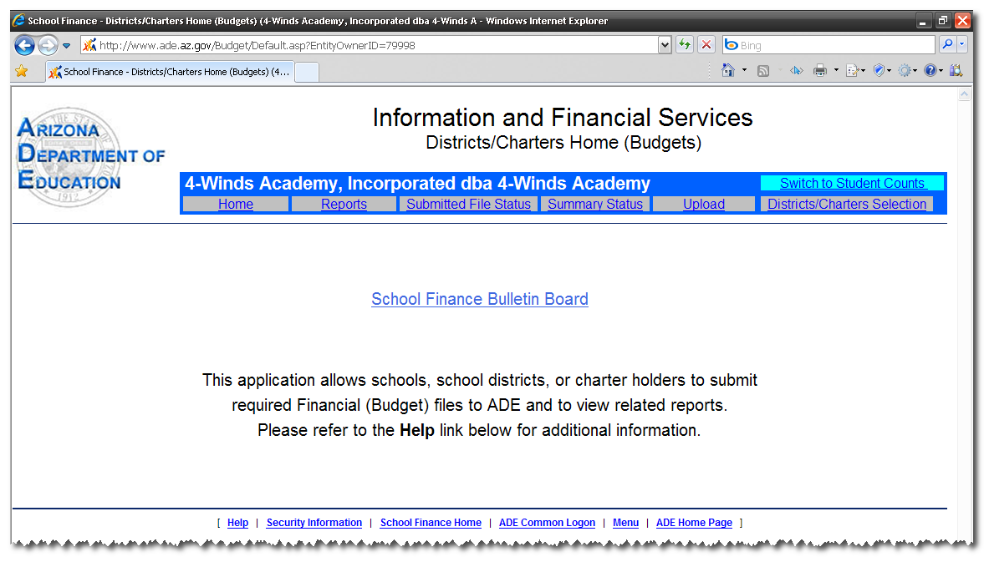

- Click the link “Submitted File Status”.

7) Select the “Display Options” Link.
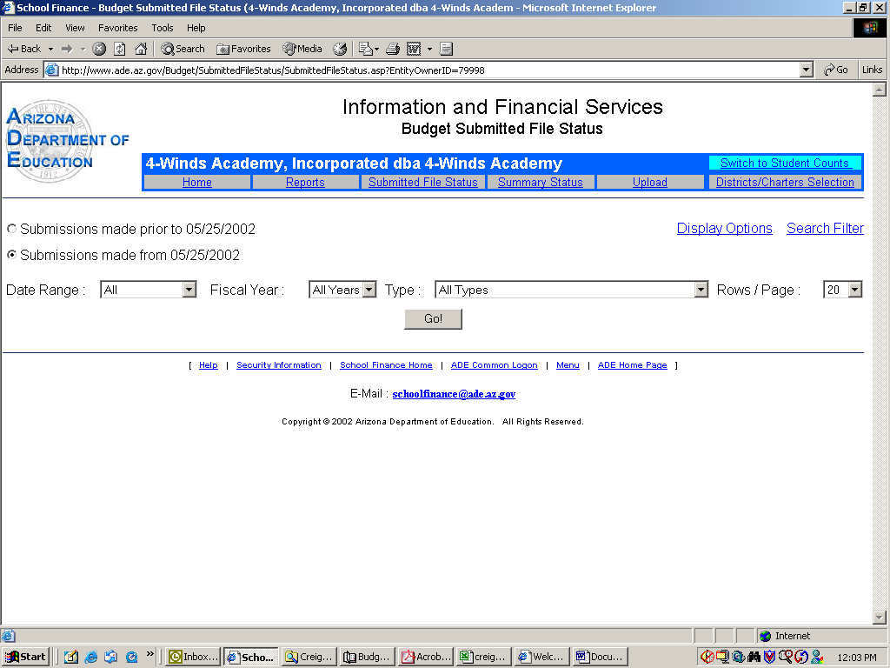

- Check boxes to display desired columns of detail and then click “Submit”.
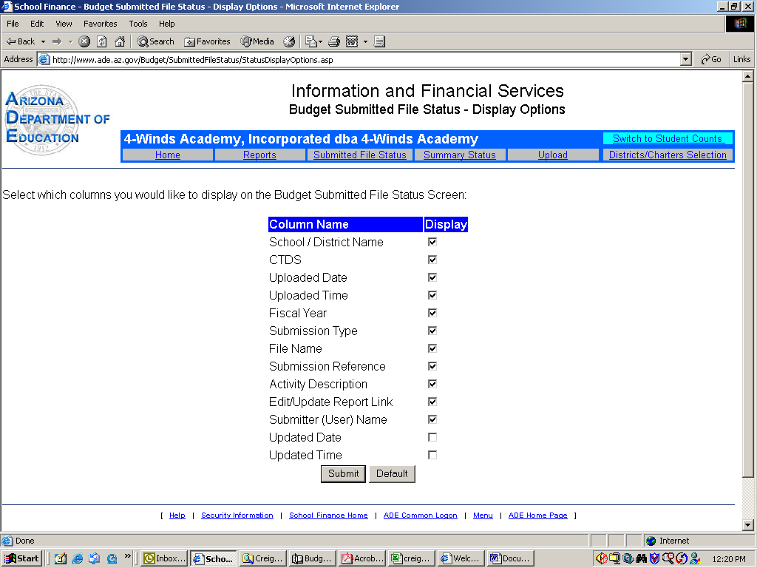

- After clicking the SUBMIT button you will be sent back to the Submitted File Status web page.

Submitted file status screen
(A) Select the Date Range (Default set to “All”),
(B) Select the Fiscal Year that you are looking for (or leave it at the default "All Years" — if not sure which year you are looking for)
Note: This will normally create a list of several files unless a specific file type is Select as described in next step (C)
(C) Select the Type of file you are looking for (if you do not know what file you are looking for leave at the default “All Types”
(D) Keep the radial button selected on “Submissions made from 05/25/2002”
(E) Then click the “Go”

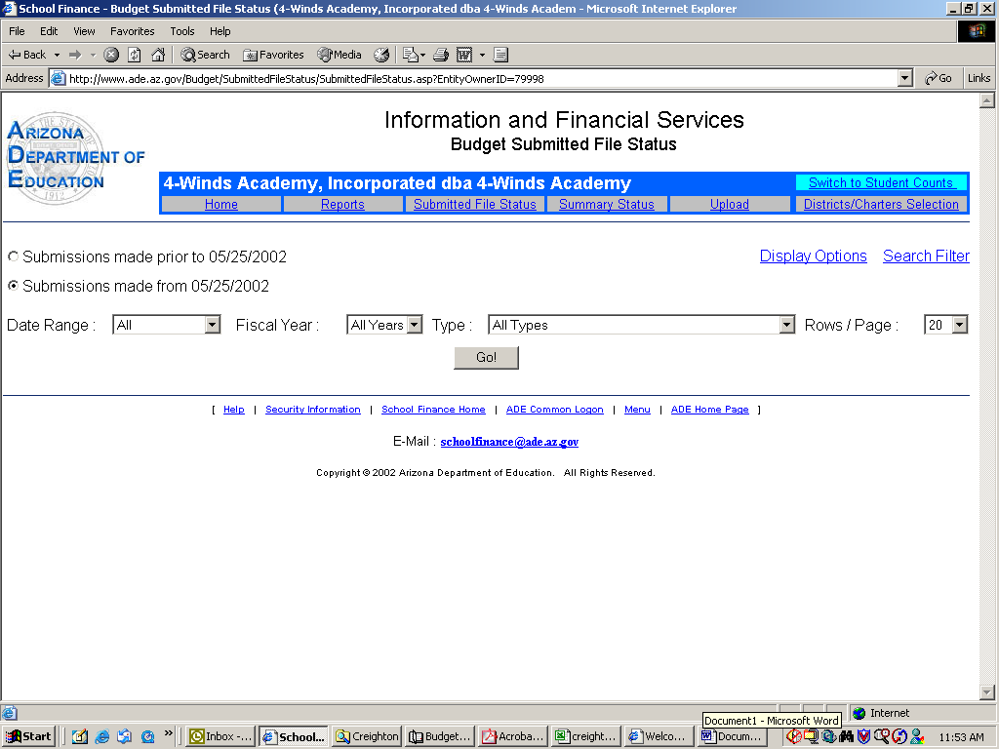
A

B
C
E

D

* You can select the “Rows/Page” to your own preference*

10)This screen will give you the details you need to determine:
A What date the file was submitted,
B Upload time,
C Fiscal Year the report is for,
D Submission type (i.e. proposed budget, adopted budget, Annual Financial Report)
E The file name,
F the reference number for the upload,
G the activity description, if the file processed successfully, failed, or is being held for processing,
H and who submitted the file

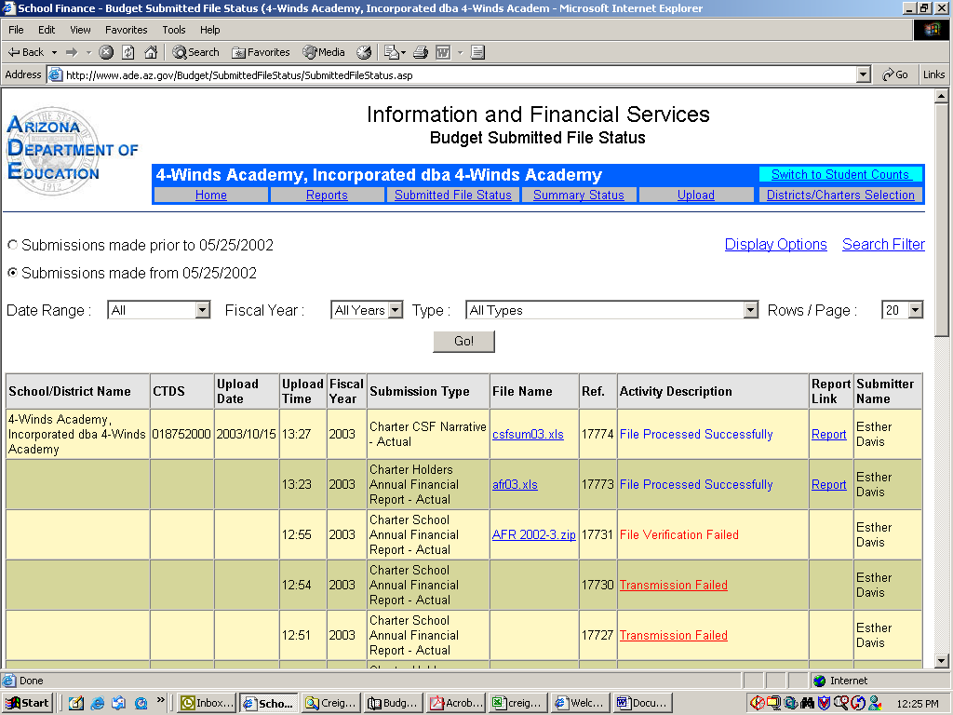

A
B
C
D
E
F
G
H

To view a specific report that was uploaded, click on the blue link in the “File Name” column. NOTE: You can only do this if the file extension is (.xls) for Excel .
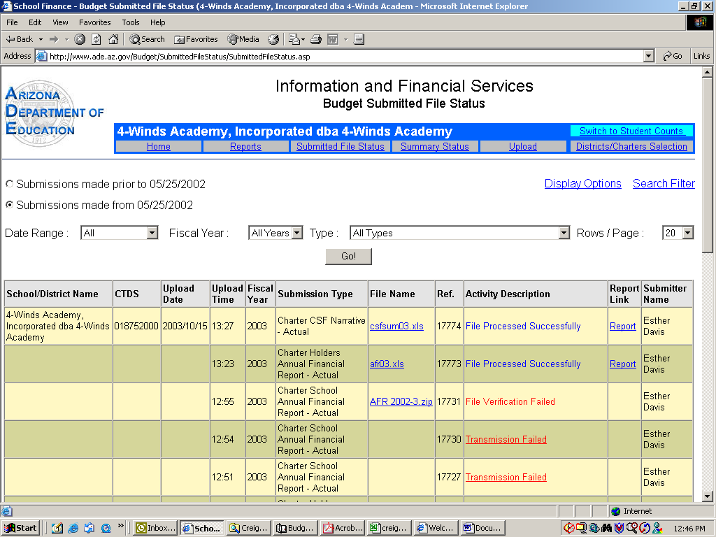

- After clicking the file link you will get a screen with a dialogue box that asked you if you want to update the link. Select “NO” **NOTE: you will not get this dialog box for the district revenue budgets.
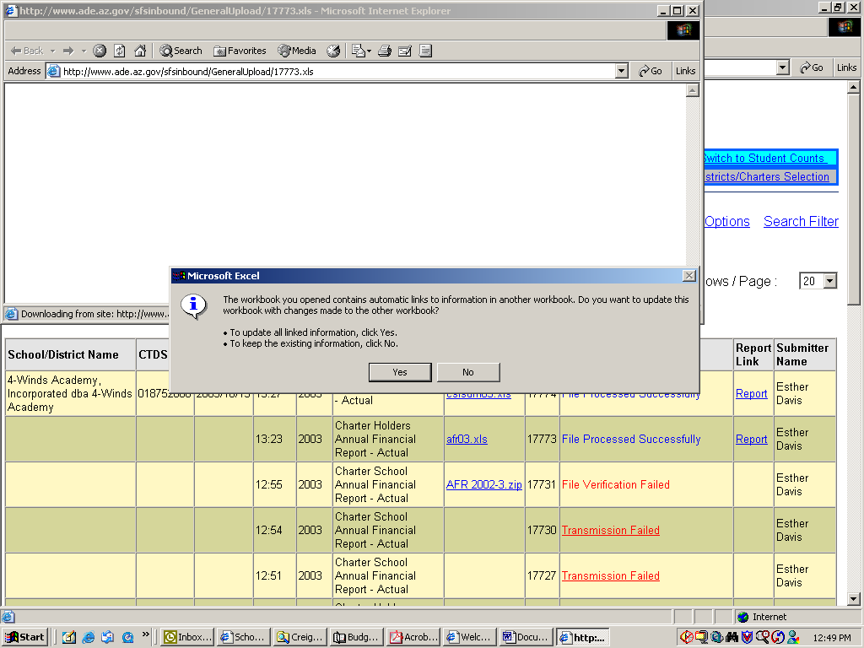

If you do not get this dialog box please check to see if you have any Excel files open. If you do please select the excel file and the above mentioned dialog box should appear. Please follow the above directions to finish viewing the file.
- A new window will open with the selected excel file for you to review.

- Click the link titled “District/Charter Selection” if you want to review a different district/charter reports. This will return you to the Internet window that has the submitted file status page. (Step 3)
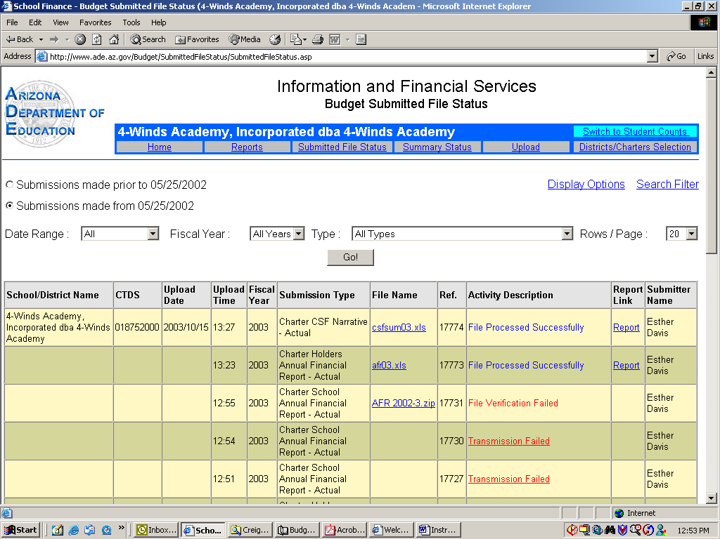

- Repeat steps 3 through 10

